**Esercizio**

Data la seguente configurazione.

Rappresentare le tabelle di routing di R2, R1 ed R3

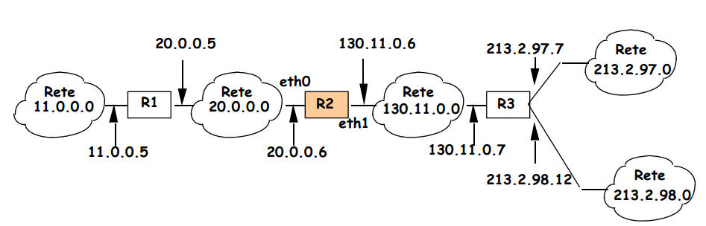

Tabella di R2

|  |  |  |  |
| --- | --- | --- | --- |
| **Destinazione N** | **Maschera M** | **Next Hop NH** | **Interfaccia I** |
| 20.0.0.0 | 255.0.0.0 | 20.0.0.6 | eth0 |
| 130.11.0.0 | 255.255.0.0 | 130.11.0.6 | eth1 |
| 11.0.0.0 | 255.0.0.0 | 20.0.0.5 | eth0 |
| 213.2.97.0 | 255.255.255.0 | 130.11.0.7 | eth1 |
| 213.2.98.0 | 255.255.255.0 | 130.11.0.7 | eth1 |

Tabella di R1

|  |  |  |  |
| --- | --- | --- | --- |
| **Destinazione N** | **Maschera M** | **Next Hop NH** | **Interfaccia I** |
| 20.0.0.0 | 255.0.0.0 | 20.0.0.5 | Eth1? |
| 130.11.0.0 | 255.255.0.0 | 20.0.0.6 | Eth1? |
| 11.0.0.0 | 255.0.0.0 | 11.0.0.5 | Eth0? |
| 213.2.97.0 | 255.255.255.0 | 20.0.0.6 | Eth1? |
| 213.2.98.0 | 255.255.255.0 | 20.0.0.6 | Eth1? |

Tabella di R3

|  |  |  |  |
| --- | --- | --- | --- |
| **Destinazione N** | **Maschera M** | **Next Hop NH** | **Interfaccia I** |
| 20.0.0.0 | 255.0.0.0 | 130.11.0.6 | Eth0? |
| 130.11.0.0 | 255.255.0.0 | 130.11.0.7 | Eth0? |
| 11.0.0.0 | 255.0.0.0 | 130.11.0.6 | Eth0? |
| 213.2.97.0 | 255.255.255.0 | 213.2.97.7 | Eth1? |
| 213.2.98.0 | 255.255.255.0 | 213.2.98.12 | Eth1? |